Eric Rouse

Individual Assignments #58

Assignment: Section 9.5: 10, 14, 26a,b,c

# Q10

Because all vertices have even degree an euler circuit exists. Thus it is possible for someone to walk all bridges exactly once and return to the same starting point.

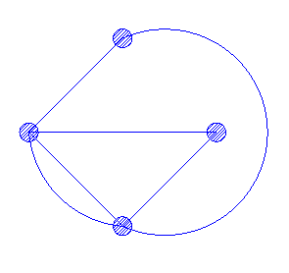

# Q14

Because there are exactly two vertices w/odd degree an euler path exists. Thus it is possible to draw the picture in the manner specified.

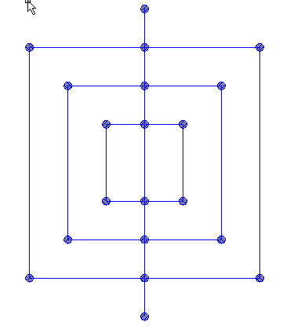

# Q26

1. 2 and all odd n.
2. All n
3. None